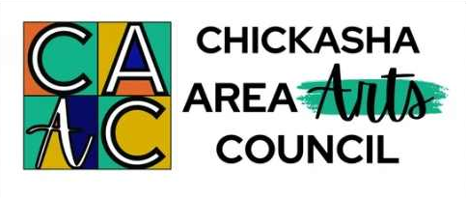

**Arts Council Accepting ArtScope 2025 Co-Director Applications**

**The Chickasha Area Arts Council (CAAC) has begun planning for its 27th annual ArtScope day camp and is accepting applications from individuals interested in being considered as a Co-Director of the 2025 ArtScope program.**

**Deadline for submission of an application and resume is Sat., Nov. 16, 2024.**

**ArtScope is a two-week multi-arts day camp for approximately 80 children, ages 8-12. The camp is June 2-13, 2025 from 9am-4pm on the USAO Campus in Chickasha, OK.**

**The Co-Director position involves coordinating and overseeing all aspects of ArtScope. It is a contracted and stipend-paid position with many responsibilities, including: planning and working with camp staff; fundraising (including grant applications, seeking donations for camper scholarships, etc.); documenting all aspect of the program; writing and submitting final grant reports; receiving and organizing all camper applications and following up with required camper information; setting up for camp, completing an inventory and storing supplies and equipment after camp; communicating with parents/guardians of campers and the CAAC Board of Directors; promoting the camp in the community via several different media; selecting CITs (Counselors-in-Training) to assist with the camp; arranging for guest artists; and being involved in every facet of the camp for several months throughout the year.**

**To obtain an ArtScope Co-Director application, visit the Arts Council’s website** [**www.chickashaarts.org**](http://www.chickashaarts.org)**, email** [**chickashaarts@gmail.com**](mailto:chickashaarts@gmail.com)**, or contact the CAAC office at 521 W. Chickasha Ave. and phone 405-448-5036.**

**In order to be considered for a Co-Director position, the completed application and up-to-date resume must be received by the Arts Council by Sat., Nov. 16, 2024.**

**The CAAC’s mailing address is “ArtScope 2025, PO Box 505, Chickasha, OK 73023-0505”. The application may be brought to the CAAC’s office located at 521 W. Chickasha Avenue, Chickasha, OK or left in the outside CAAC drop box between the two entrances.**

**The Chickasha Area Arts Council is a non-profit 501(c)3 all-volunteer organization governed by a Board of Directors. Activities and events of the CAAC are funded by memberships, individuals, businesses, clubs, and organizations. ArtScope is also supported by the Oklahoma Arts Council (OAC) and the National Endowment for the Arts (NEA).**